**DAILY ASSESSMENT REPORT**

|  |  |  |
| --- | --- | --- |
| **DATE** | **21/05/2020** | NAME **K GAURAV SHET** |
| **COURSE** | TCSiON | USN **4AL18EC023** |
| **TOPIC** | 1.**Learn corporate telephone etiquette**  **2.Understand Accounting fundamentals**  **3.Gain fundamental skills in IT** | **SEM 4th sem.A sec**  **sections** |
| **Github Repository** | **Gaurav-shet** |  |

**FORENOON SESSION DETAILS**

**Image of session**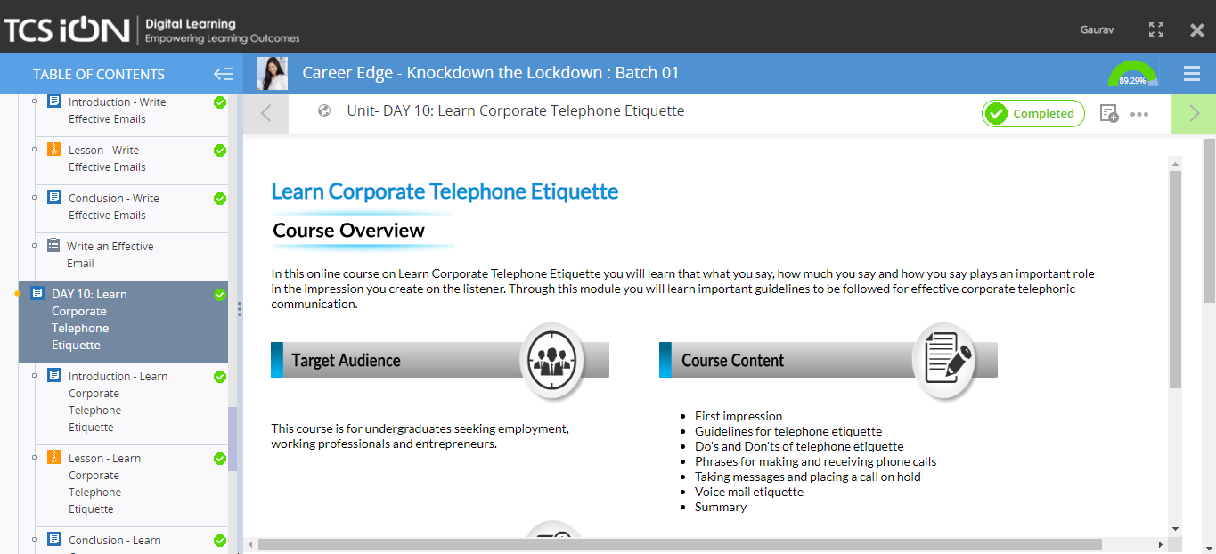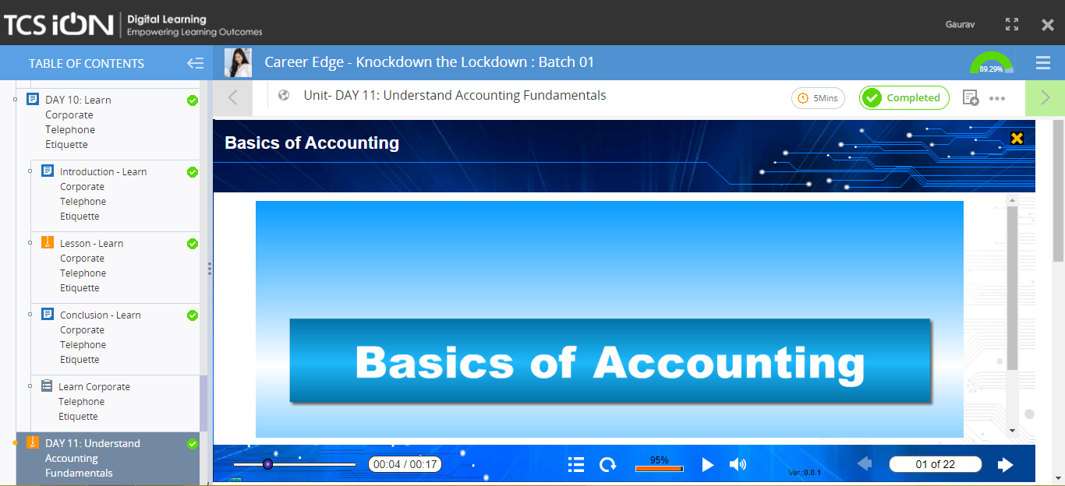

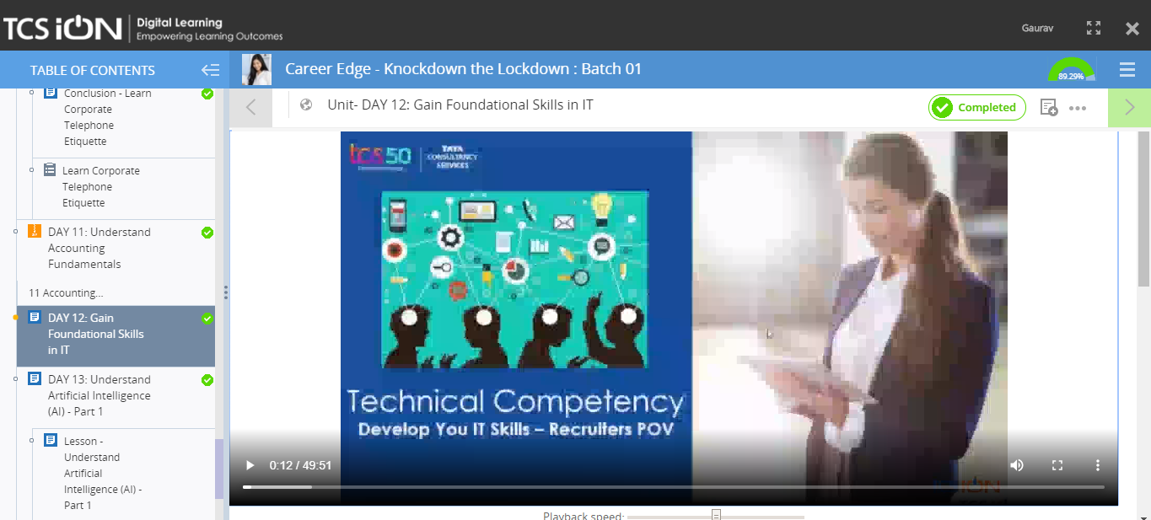

**TOPIC 1:Day 10: Learn Corporate Telephone Etiquette**

**In this module we learnt**

**The basic manners that we should follow while having telephonic contact with other person**

**Also learnt some DO’s and DONT’s in telephonic contact**

**TOPIC 2:Day 11: Understand the Accounting fundamentals**

**In this topic we learnt**

* **Basics of Accounting**
* **Cycle of Accounting**
* **Income and ledger**
* **Etc**

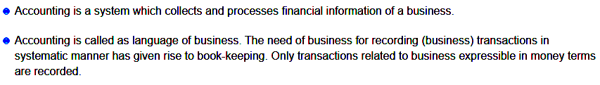

**Topic 3: Gain fundamentals skills in IT**

**This module gives a clear picture of How a Graduate person must acquire skills in IT.**

**AFTERNOON SESSION DETAILS**

|  |  |  |  |
| --- | --- | --- | --- |
| **DATE** | **21/05/2020** | **Name** | **K Gaurav shet** |
| **COURSE** | **Python for machine learning by great learning and morsh python** | **USN** | **4al18ec023** |
| **Topics** | **1.Conditional loops**  **2.Functions and user defined functions**  **3.Introduction to NumPy**  **4.Introduction to Pandas** | **Sem and section** | **4th sem.A SEC ECE** |
| **Github repository** | **Gaurav-shet** |  |  |

**Images and report of the session:**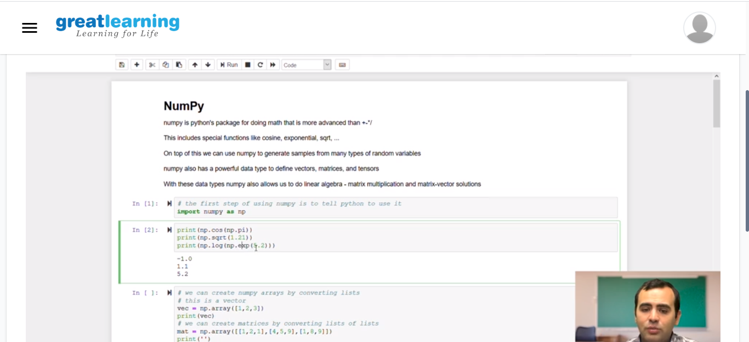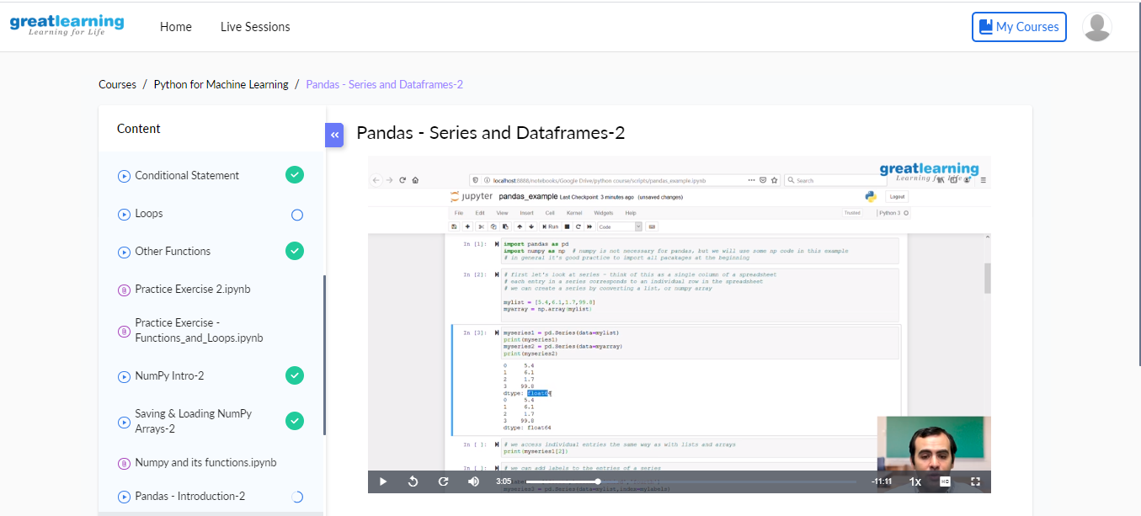

**Introduction to loops used in python:**

**The major loops and Conditional loops of python is:**

1. **if**
2. **else**
3. **elif**
4. **for**
5. **etc,**

**Introduction to NumPy**

**NumPy is pythons Package for doing math, that is more advanced than +,-, %,\***

**This includes specifications like cosines, exponentials, sqrt…..**

**This is used to generate much type of random variables**

**NumPy also has a powerful data type to define, vectors, matrices and linear algebra, matrix multiplications etc.**

**Operations performed on NumPy:**

1. **array**
2. **arrange**
3. **linspace**
4. **reshape**
5. **Zeros**
6. **Saving and loading numpy arrays**

**Etc.**

**Introduction to Pandas:**

**It is package use in python for managing data**

**It use is that it creates 2 new data type for storing data, series and datafrme**